Screenshots

Problem 1:

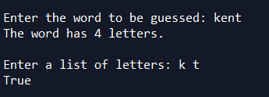

*Letters k and t is part of the word kent. Therefore true*

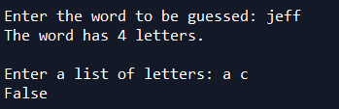

*Letters a and c is not part of the word jeff. Therefore false*

Problem 2:

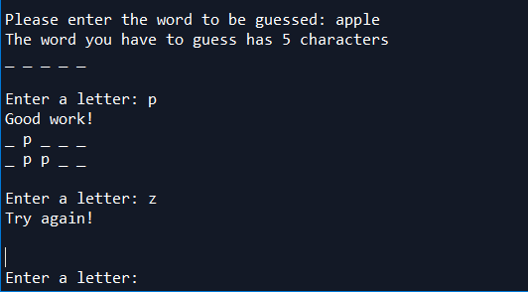

*Entering a correct letter fills the blank, while entering the letter prompts you to enter a letter again.*

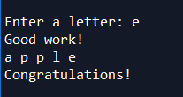

*When you guessed it right.*

Problem 3:

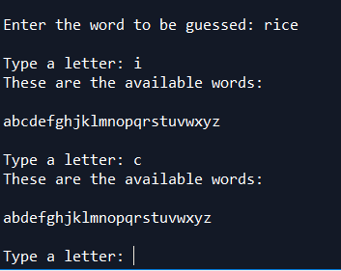

*I and C are removed from the list of letters.*

Hangaroo Game

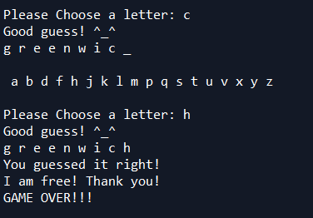

*Winning the game*

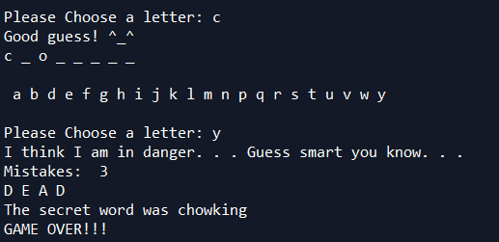

*Losing the game*